Ideation Phase
Empathize & Discover

Date | 31 January 2026
Team ID | LTVIP2026TMIDS35041
Project Name | Measuring The Pulse Of Prosperity: An Index Of Economic Freedom Analysis
Maximum Marks | 4 Marks

Empathy Map Canvas:
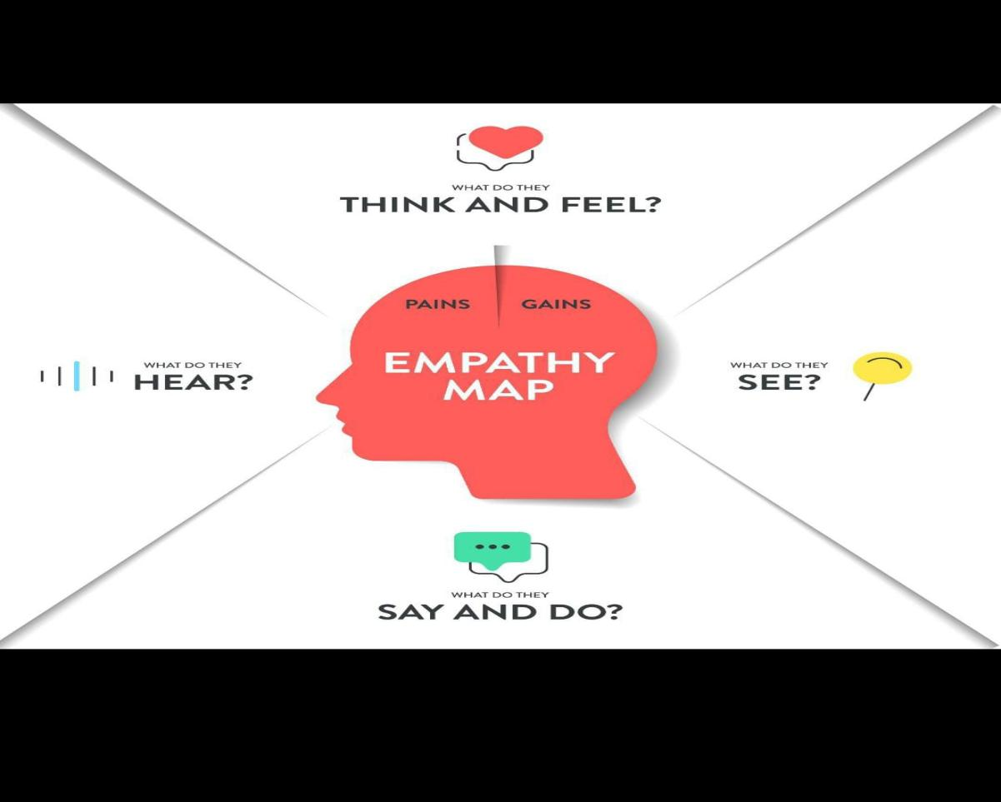
THINK & FEEL
Which countries have the highest and lowest economic freedom in 2022?
How does economic freedom vary across different regions?
Are inflation, GDP growth, and unemployment impacting economic freedom?
I need accurate insights to support academic and policy decisions.
Concerned about misinterpreting complex economic indicators.
SEE
Large datasets with multiple economic indicators.
Country-wise and region-wise economic freedom scores.
Dashboards showing maps, bar charts, and trend comparisons.
Visual differences between developed and developing economies.
Rankings of top and bottom countries.
HEAR
“Economic freedom affects national growth and investments.”
“Data visualization makes analysis easier than raw tables.”
“Tableau dashboards help identify trends quickly.”
“Region-wise comparison is important for policy decisions.”
“Correlation analysis reveals hidden economic relationships.”
SAY & DO
Uses Tableau dashboards to explore data interactively.
Compares countries and regions using charts and maps.
Filters data to focus on specific indicators like inflation or GDP.
Shares insights through dashboards and stories.
Interprets trends for reports and presentations.

